How to Create Zero Node on Pecuniaplatform
- Visit pecuniaplatform.io for ZERO masternode hosting, Create account, and add some funds ($1 is required for 1 node /month hosting).
- Click on Dashboard > Host
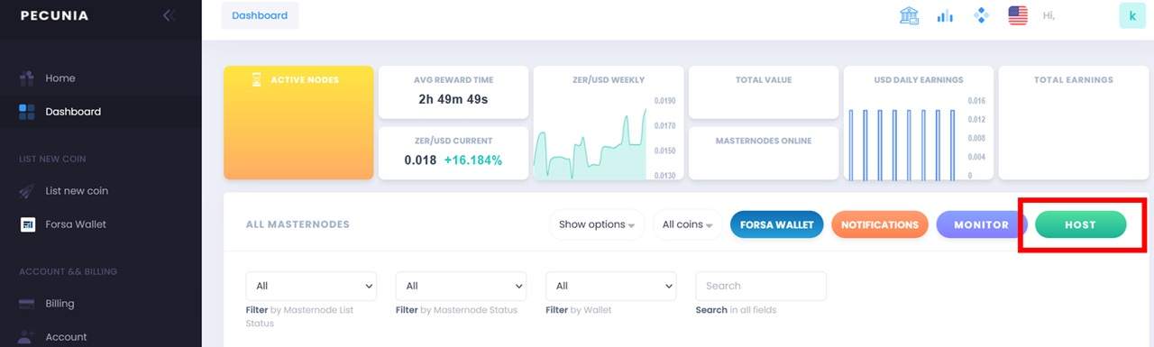
- Search for ‘Zero’ from drop list.
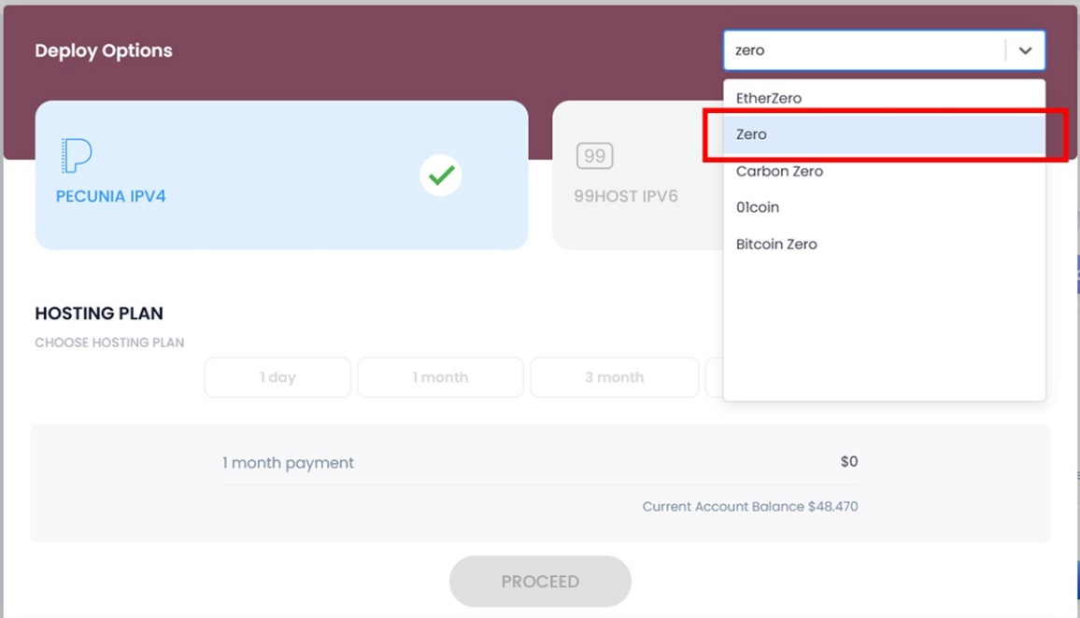
- Chose hosting plan and click on ‘PROCEED’.
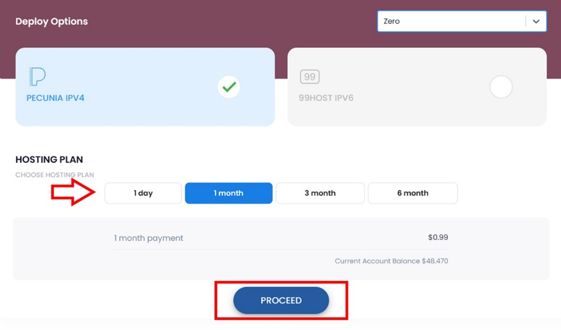
- Send 10,000 ZER in one transaction (no problem if there were multiple inputs, but it should be one 10,000 ZER output) to the address you own.
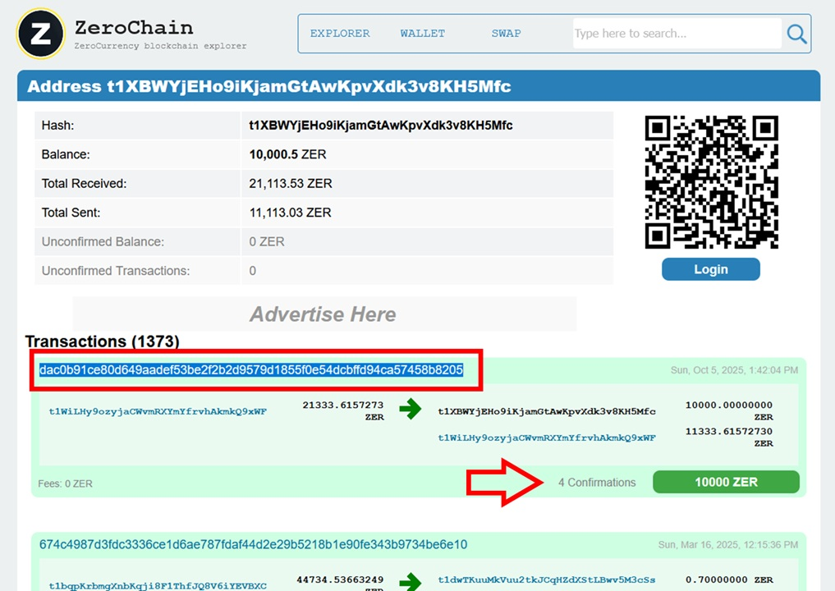
- Copy ‘transaction ID’ and paste it on pecuniaplatform, then click on ‘CHECK’.
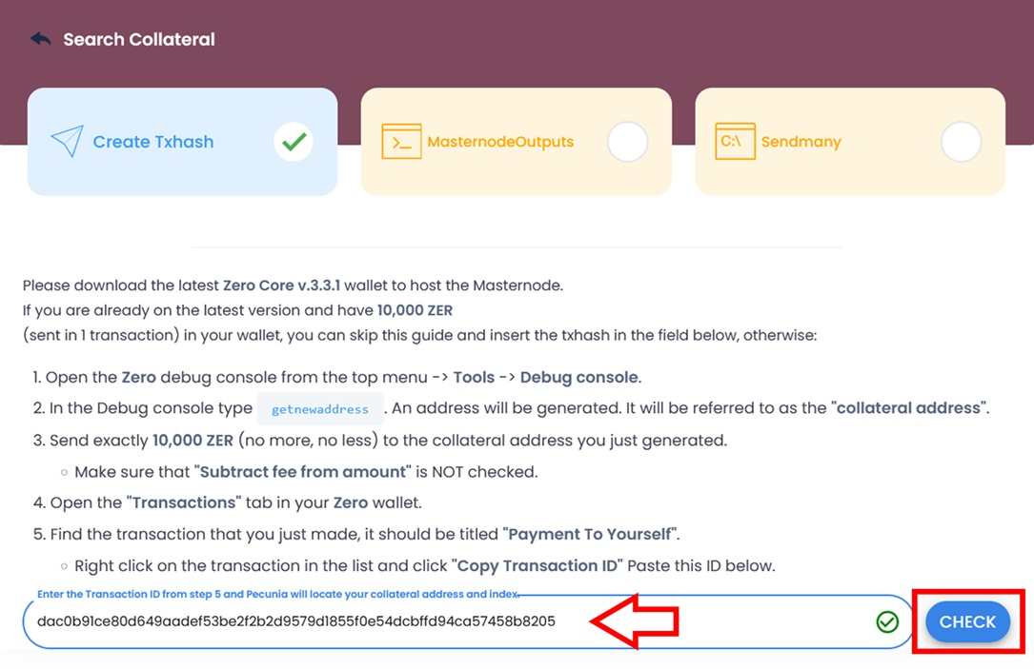
- Just double check that you choose output equal to your masternode address with 10,000 ZER. Usually default is correct, but double check that mark is on output of your address and 10,000 ZER, then click on ‘CONTINUE’.
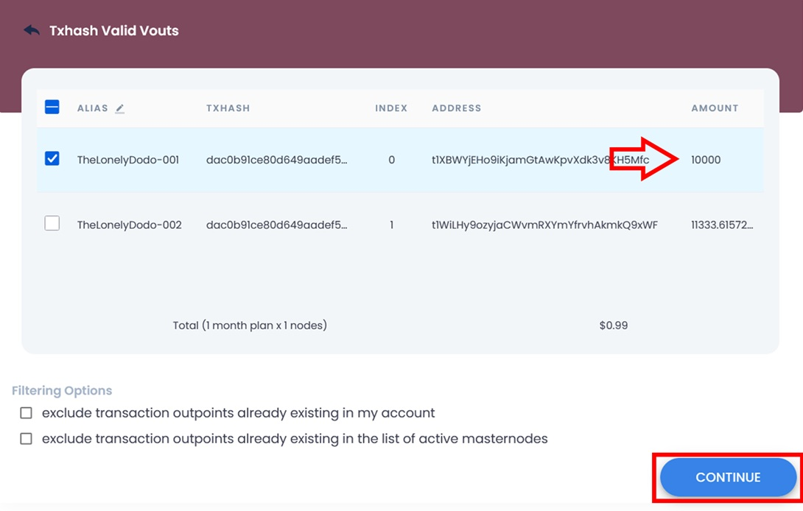
- Click on ‘DEPLOY SERVER’.
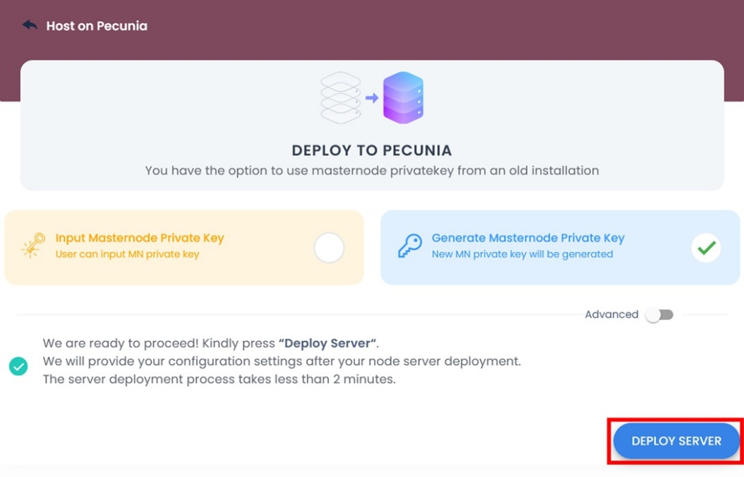
- Download ZERO core wallet and import your ZERO address.
ZERO core download for Windows:
https://github.com/zerocurrencycoin/zerowallet/releases/download/v2.0.0/Windows-zerowallet-330.zip
ZERO core download for MacOS:
https://github.com/zerocurrencycoin/zerowallet/releases/download/v2.0.0/macOS-zerowallet-v2.0.0.dmg
ZERO core download for Linux:
https://github.com/zerocurrencycoin/zerowallet/releases/tag/v2.0.0
Keet wallet open for few hours (depending on your internet connection) required to download ~5 G.B ZERO blockchain and sync it.
When wallet sync is complete, Import your Zero address (which received 10,000 ZER).
Zero Core Wallet > File > Import private key.
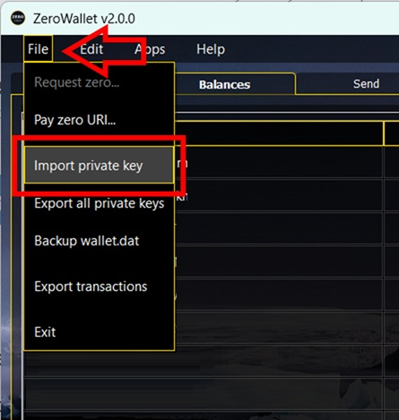
You can get private key exported from Zerochain wallet if you had used Zerochain to generate your address (Export > Private Keys).
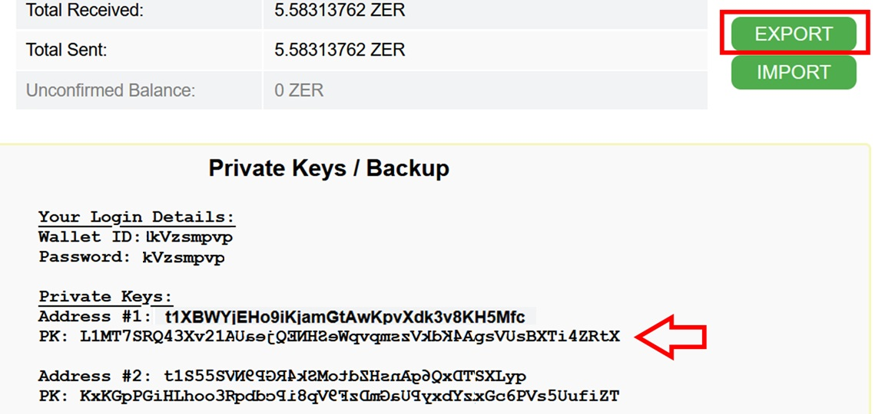
Copy address private key and paste it into filed, then click on ‘OK’.
You will need to wait some minutes till Zero Core Wallet fully import your address and sync it. Sometimes this action may takes up-to 30 minutes to fully sync new address.
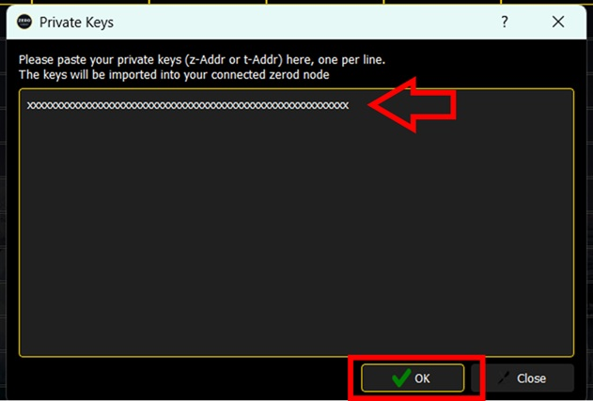
- Your hosted Masternode should by syncing too.
Here are masternode status you will see on pecuniaplatform.
Mostly you will need to come back after few hours, till Hosted node and Zero wallet core are fully synced.
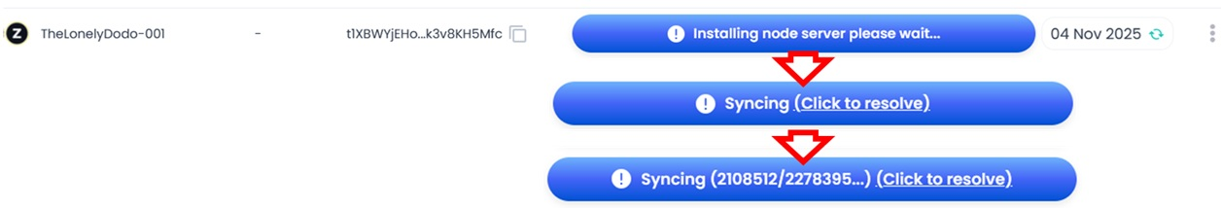
- Add your Masternode into Zero core wallet when both masternode and Zero core wallet are synced.
Zero core wallet > ZeroNodes > New ZN.
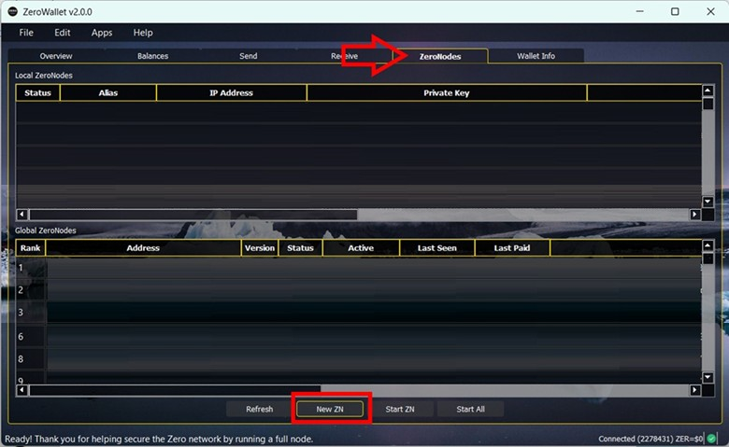
- Copy masternode details from hosting, and submit into Zero core wallet.
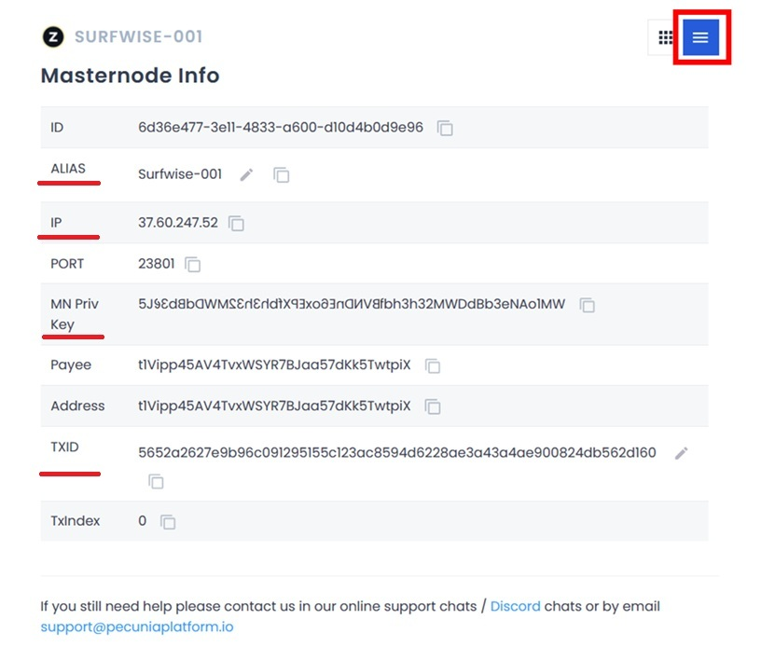
Alias = ALLIAS
IP Address = IP
Private Key = MN Priv Key (this is new generated private key for Masternode, not for address)
Output = TXID (this is transaction ID which carried 10,000 ZER)
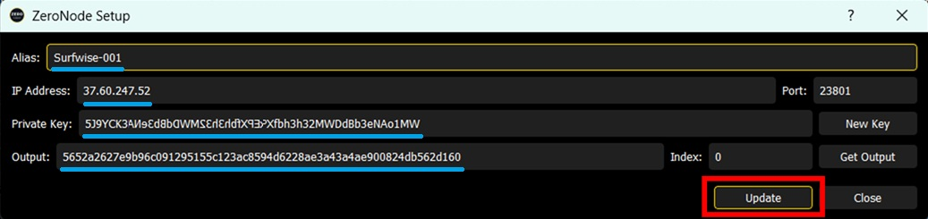
Your node is READY.
You will see rewards added to your address balance on Zero core wallet.
To claim rewards, you need to ‘Shield balance to Sapling’ first by sending it to Private Address (generated by Zero core wallet).
Make sure to backup your wallet before claiming rewards, then right click by mouse on your address > Shield balance to Sapling.
This will transfer claimable rewards (and keep 10,000 ZER) to your Private address.
Wait few minutes for confirmation, then you can send rewards from private address to any other address.
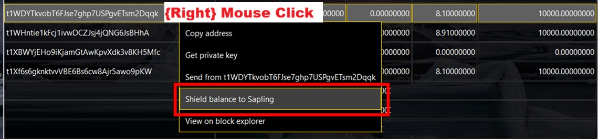
Good luck!
Donations are welcomed:
ZER : t1WYq17CbrQXWQiCPLEnDqtEUThcDDZzN1B

